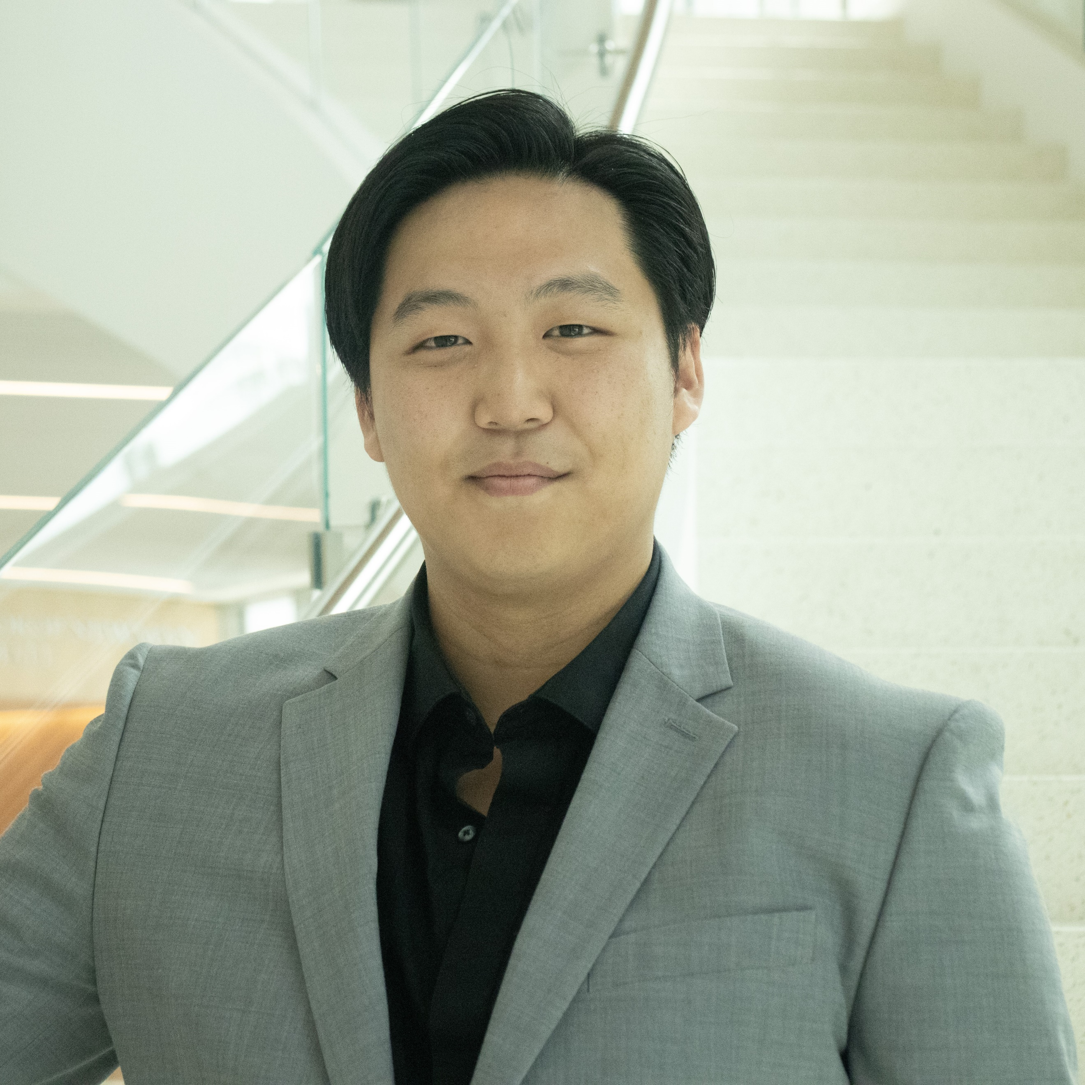**Theodore Chang**, Baritone Contact: [theodore.chang001@gmail.com](mailto:theodore.chang001@gmail.com) | 917-789-4462 <https://www.theodorechangbaritone.com>

**Upcoming** The Editor Notes on Viardot Music on Site December 2024 Featured Artist Opera Scenes Showcase Music on Site December 2024 Chorus L’Elisir d’Amore Florida Grand Opera February 2025 Chorus Carmen Florida Grand Opera April 2025

**Opera** Il Commendatore Don Giovanni Chicago Summer Opera 2024 Masetto Don Giovanni Chicago Summer Opera 2024 Mr. Jones Street Scene Frost Opera Theatre 2024 Papageno Die Zauberflöte QSVI Opera 2023 Antonio Le Nozze di Figaro Frost Opera Theatre 2023

**Partial Roles/Scenes**  St. Brioche The Merry Widow Frost Opera Theatre 2023 Steward Flight Frost Opera Theatre 2023 Alcindoro La Bohème Frost Opera Theatre 2023 Figaro Il Barbiere di Siviglia Si Parla, Si Canta 2023 Il Conte Robinson Il Matrimonio Segreto Si Parla, Si Canta 2023 Don Alfonso Così fan Tutte Frost Opera Theatre 2021 The Baritone The Four Note Opera Frost Opera Theatre 2021

**Ensemble/Soloist**  Ensemble Celestial eVoco Voice Collective 2024 Bass Soloist Beethoven’s Ninth Symphony Frost Chamber Singers 2024 Ensemble The Leopard (World Premiere) Frost Opera Theatre 2022

**Education** University of Miami, Frost School of Music*, Coral Gables, FL* August 2020-May 2024 Bachelor of Music, *Vocal Performance*

**Training Programs** Chicago Summer Opera, *Chicago, IL* Summer 2024 Queens Summer Vocal Institute*, Flushing, NY*  Summer 2023 Si Parla, Si Canta, *Arona, Italy* Summer 2023 Frost School of Music at Salzburg, *Salzburg, Austria* Summer 2022

**Masterclasses** Viktoria Vizin, *Chicago, IL* July 2024 Linda di Fiore, *Miami, FL* November 2023 Elizabeth Norberg-Schulz, *Arona, Italy* June 2023 Vladmir Chernov, *Salzburg, Austria*  July 2022

|  |  |  |  |
| --- | --- | --- | --- |
| **Teachers**  Kim Josephson  Allan Glassman  Chris Merritt | **Coaches**  Gyan Singh Maria  Jenny Snyder Elaine Rinaldi Hemdi Kfir Brett Hodgdon | **Conductors**  Curtis Serafin  Gerard Schwarz Amanda Quist Yun Cao Alan Johnson | **Directors**  Cathleen Dunn  Jeffery Buchman Alexander Paul Sheerin |